Solution Architecture
Date
Team ID | xxxxxx
Project Name | EduGenie: Google Gemini Powered Learning Assistant
Maximum Marks | 5 Marks

Solution Architecture Diagram:
High-level view of EduGenie's Presentation Layer, Application (API + logic) Layer, AI integrations and Data Layer.
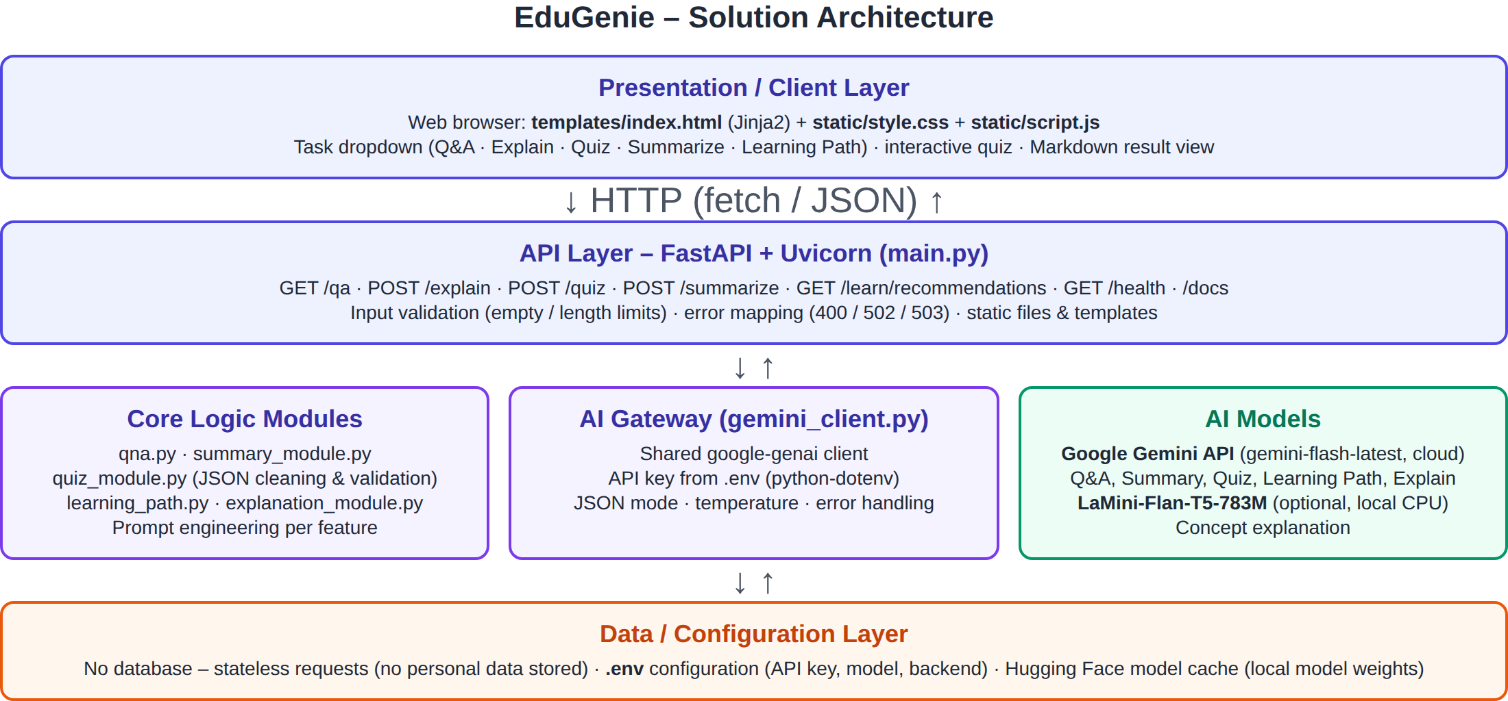
Figure: EduGenie solution architecture
Request Flow
- The student selects a task and submits input in the browser (index.html + script.js).
- script.js sends a fetch() request (GET/POST JSON) to the matching FastAPI endpoint.
- main.py validates the input and calls the feature module (qna, explanation, quiz, summary, learning_path).
- The module builds a task-specific prompt and calls Gemini through gemini_client.py (or the local LaMini-Flan-T5 model for explanations).
- The response is cleaned/validated (quiz JSON) and returned as JSON; the browser renders it (formatted text or interactive quiz).
Component Description Table
Component Name | Description / Role in Architecture | Technologies Used
Presentation Layer | Single-page UI: task dropdown, input area, options (quiz size, level), results with Markdown rendering, interactive quiz and score, status badge. | HTML5, Jinja2, CSS3, JavaScript (Fetch API)
API Layer (FastAPI) | Exposes REST endpoints, validates input, maps errors to HTTP status codes, serves templates/static files and API docs. | FastAPI, Uvicorn, Pydantic
Core Logic Modules | One module per feature with its own prompt: qna.py, explanation_module.py, quiz_module.py, summary_module.py, learning_path.py. | Python 3.10+
AI Gateway & Models | gemini_client.py manages the API key, model name, JSON mode and errors; Gemini generates content; LaMini-Flan-T5 explains concepts locally. | google-genai SDK, Gemini (gemini-flash-latest), transformers, torch
Data / Configuration | Stateless - no database. Configuration (API key, model, explanation backend) read from .env. | python-dotenv, .env file

